**CHAPTER 1**

**INTRODUCTION**

1. **Computer Graphics** 
   * Graphics provides one of the most natural means of communicating with a computer, since our highly developed 2D or 3D pattern-recognition abilities allow us to perceive and process pictorial data rapidly.
   * Computers have become a powerful medium for the rapid and economical production of pictures.
   * Graphics provide a so natural means of communicating with the computer that they have become widespread.
   * Interactive graphics is the most important means of producing pictures since the invention of photography and television.
   * We can make pictures of not only the real world objects but also of abstract objects such as mathematical surfaces on 4D and of data that have no inherent geometry.
   * A computer graphics system is a computer system with all the components of the general purpose computer system. There are five major elements in system: input devices, processor, memory, frame buffer, output devices.

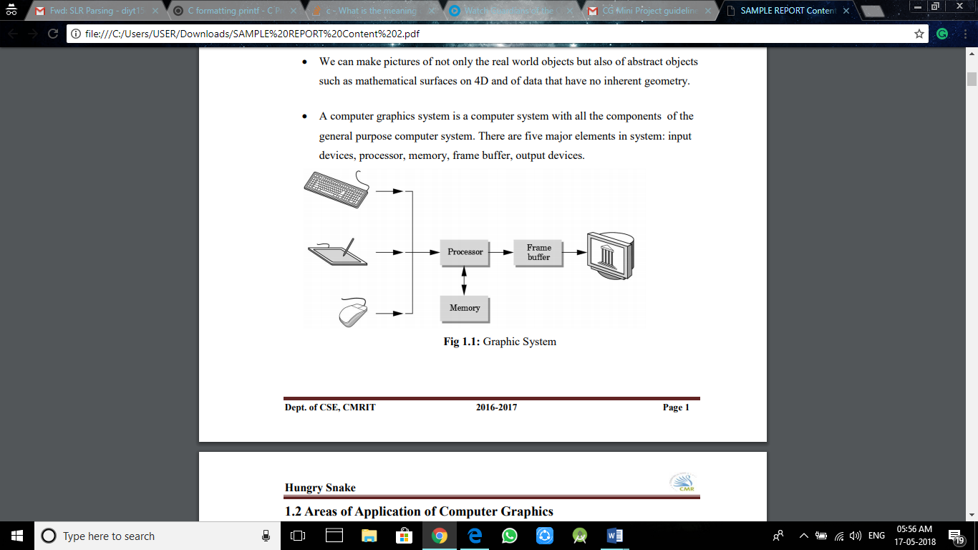

**Fig 1.1:** Graphic System

1. **Areas of Application of Computer Graphics**

* User interfaces and Process control
* Cartography
* Office automation and Desktop publishing
* Plotting of graphs and charts
* Computer aided Drafting and designs
* Simulation and animation
* Virtual Designing
* Video games
* Web design

1. **Introduction to OpenGL**

**OpenGL** is the premier environment for developing portable, interactive 2D and3D graphics applications. Since its introduction in 1992, OpenGL has become the industry's most widely used and supported 2D and 3D graphics application programming interface (API), bringing thousands of applications to a wide variety of computer platforms.

**OpenGL** fosters innovation and speeds application development byincorporating a broad set of rendering, texture mapping, special effects, and other powerful visualization functions. Developers can leverage the power of OpenGL across all popular desktop and workstation platforms, ensuring wide application deployment.

**OpenGL** available Everywhere: Supported on all UNIX® workstations, andshipped standard with every Windows 95/98/2000/NTandMacOS PC, no other graphics API operates on a wider range of hardware platforms and software environments.

**OpenGL** runs on every major operating system including Mac OS, OS/2, UNIX,Windows 95/98, Windows 2000, Windows NT, Linux, Open Step, and BeOS; it also works with every major windowing system, including Win32, MacOS, Presentation Manager, and X-Window System. OpenGL is callable from Ada, C, C++, Fortran, Python, Perl and Java and offers complete independence from network protocols and topologies.

**1.3.1 The OpenGL interface**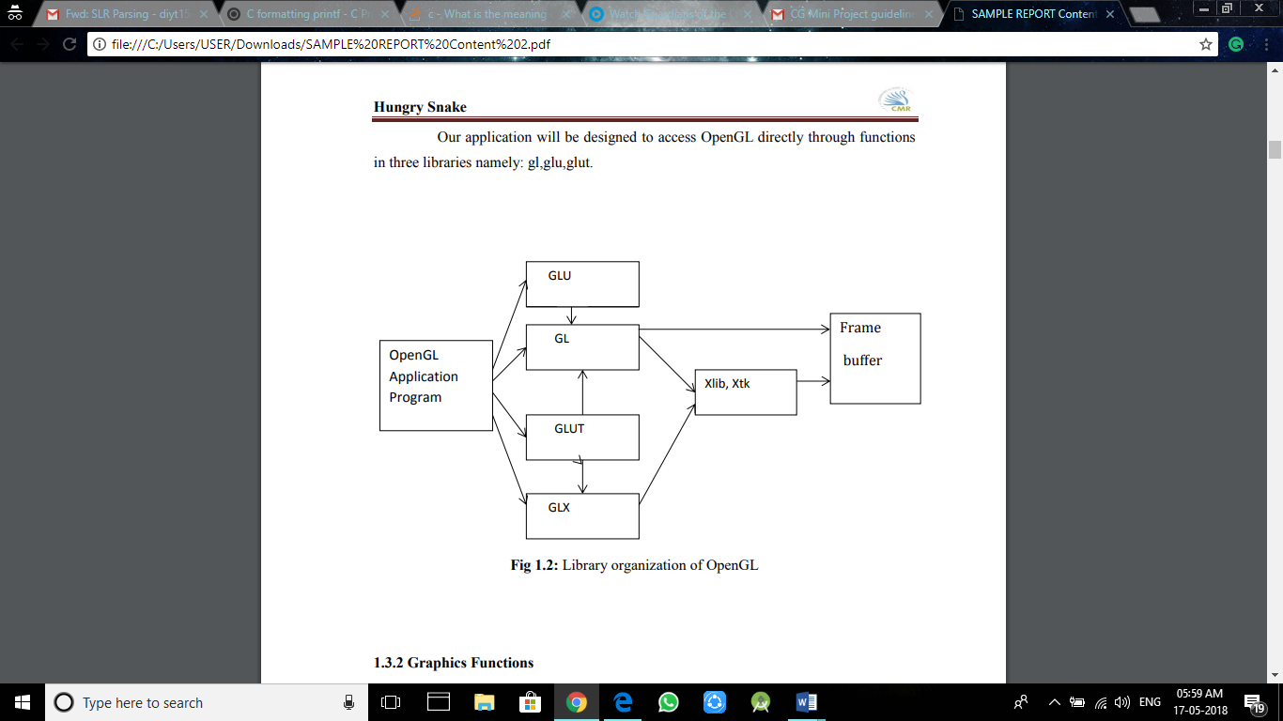

Our application will be designed to access OpenGL directly through functions in three libraries namely: gl,glu,glut.

**Fig 1.2:** Library organization of OpenGL

**1.3.2 Graphics Functions**

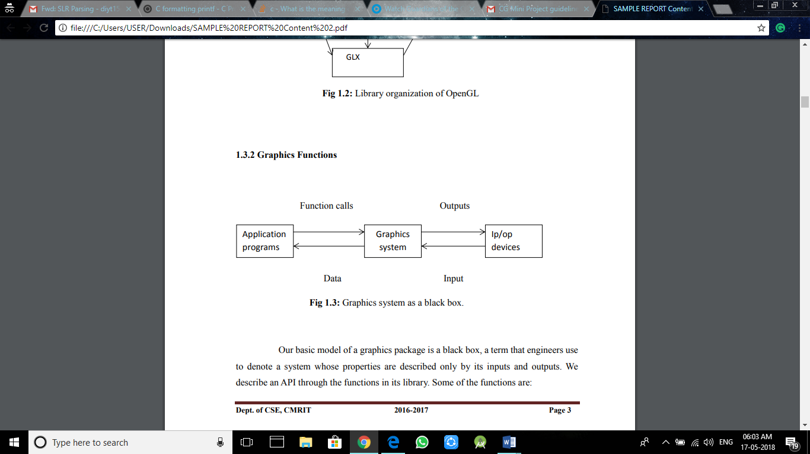

**Fig 1.3:** Graphics system as a black box.

Our basic model of a graphics package is a black box, a term that engineers use to denote a system whose properties are described only by its inputs and outputs. We describe an API through the functions in its library. Some of the functions are:

* The primitive functions define the low-level objects or atomic entities that our system can display.
* Attribute functions allow us to perform operations ranging from choosing the color with which we display a line segment, to picking a pattern with which to fill the

inside of a polygon, to selecting a typeface for the titles of a graph.

* Transformation function allows carrying out transformations of objects, such as rotation, translation, and scaling.
* A set of input functions allow us to deal with the diverse forms of input that characterize modern graphics systems.
* The control functions enable us to communicate with the window systems, to initialize our programs, and to deal with any errors that take place during the execution of programs.

**CHAPTER 2**

**REQUIREMENTS SPECIFICATION**

**2.1 Purpose of the requirements document**

The software requirement specification is the official statement of what is required for development of particular project. It includes both user requirements and system requirements. This requirement document is utilized by variety of users starting from project manager who gives project to the engineer responsible for development of project.

It should give details of how to maintain, test, verify and what all the actions to be carried out through life cycle of project.

**2.1.1 Scope of the project**

The scope is to use the basic primitives defined in openGL library creating complex objects. We make use of different concepts such as glColor() , gluOrtho2D(), timer function.

**2.1.2 Definition**

The project **ROUTER ARCHITECTURE** is created to demonstrate OpenGL’s concepts. It encompasses some of the skills learnt in our OpenGL classes such as glColor() , gluOrtho2D(), timer function.

**2.1.3 Acronyms & Abbreviations**

OpenGL provides a powerful but primitive set of rendering command, and all higher-level design must be done in terms of these commands.

OpenGL Utility Toolkit(GLUT): -windows-system-independent toolkit.

**2.1.4 References**

OpenGL tutorials

Interactive Computer Graphics (Edward Angel)

**2.2 Specific requirements**

**2.2.1 User Requirement**:

* Easy to understand and should be simple.
* The built-in functions should be utilized to maximum extent.
* OpenGL library facilities should be used.

**2.2.2 Software Requirements:**

* Platform used: UBUNTU
* Technology used: OpenGL Libraries such has OpenGL Utility library, OpenGL Utility toolkit
* Language: C

**2.2.3 Hardware Requirements:**

| **CPU Speed** | 1.5 GHz or higher |
| --- | --- |
| **Processor** | Intel Pentium**®** or higher |
| **Memory/RAM** | 2 GB or higher (32-bit) 8 GB or higher (64-bit) |
| **Display Properties** | 24-bit colour depth |
| **Screen Resolution** | 1024 x 768 or higher at normal size (96 dpi) |
| **Swap Space** | Determined by the operating system, 500 MB or higher |
| **Disk Space** | 1 GB for installing the Platform and Synthesis Applications |
| **Video/Graphics Adapter** | 64 MB RAM or higher |

**CHAPTER 3**

**IMPLEMENTATION**

1. **OpenGL Function Details**

* **GlutInitDisplayMode**—sets the initial display mode.
  + Declaration: void glutInitDisplayMode (unsigned int mode);
  + Remarks: The initial display mode is used when creating top-level windows, sub windows, and overlays to determine the
  + OpenGL display mode for the to-be-created window or overlay.
* **glutInitWindowposition ---** set the initial window position.
  + Declaration: void glutInitWindowPosition(int x, int y);
  + x:Window X location in pixels.
  + y:Window Y location in pixels.
* **glutInitWindowSize ---** set the initial window size.
  + Declaration: void glutInitWindowSize(intwidth,int height);
  + width: Width in pixels
  + height: Height in pixels.
* **glutCreateWindow**--- set the title to graphics window.
  + Declaration: IntglutCreateWindow(char *title);
  + Remarks: This function creates a window on the display. The string title can be used to label the window.The integer value returned can be used to set the current window when multiple windows are created.
* **glutDisplayFunc**
  + Declaration: void glutDisplayFunc(void(*func)void));
  + Remarks: This function registers the display function that is executed when the window needs to be redrawn.
* **glClear:**
  + Declaration: void glClear();
  + Remarks: This function clears the particular buffer.
* **glclearColor:** 
  + Declaration: void glClearColor(GLfloat red, GLfloat green, Glfloat blue, Glfloat alpha);
  + Remarks: This function sets the color value that is used when clearing the color buffer.
* **glEnd**
  + Declaration: void glEnd();
  + Remarks: This function is used in conjunction with glBegin to delimit the vertices of an opengl primitive.
* **glMatrixMode**
  + Declaration: void glMatrixMode(GLenum mode);
  + Remarks: This function specifies which matrix will be affected by subsequent transformations mode can be GL_MODELVIEW,GL_PROJECTION or GL_TEXTURE.
* **gluOrtho2D** 
  + Declaration: void glOrtho(GLdouble left, GLdouble right, GLdoublebottom,GLdouble top);
  + Remarks: It defines an orthographic viewing volume with all parameters measured from the center of the projection plane.
* **glutInit**
  + Declaration: Void glutInit(int *argc, char **argv);
  + Remarks: To start thru graphics system, we must first call glutInit (),glutInit will initialize the GLUT library and negotiate a session with the window system. During this process, glutInit may cause the termination of the GLUT program with an error message to the user if GLUT cannot be properly initialized.

**3.2. Code in C Language**

#define GLUT_DISABLE_ATEXIT_HACK

#include <GL/gl.h>

#include <GL/glut.h>

#include <stdlib.h>

#include<string.h>

#include<vector>

float v[72][2]={{440,400},{560,400},{560,600},{440,600}, //Router

                {660,400},{940,400},{940,480},{660,480}, //Output Ports

                {660,520},{940,520},{940,600},{660,600}, //Output Ports

                {60,400},{340,400},{340,480},{60,480}, //Input Ports

                {60,520},{340,520},{340,600},{60,600},//Input Ports

                {680,410},{760,410},{760,470},{680,470}, //Output Boxes

                {770,410},{850,410},{850,470},{770,470}, //Output Boxes

                {680,530},{760,530},{760,590},{680,590}, //Output Boxes

                {770,530},{850,530},{850,590},{770,590}, //Output Boxes

                {860,420},{920,420},{920,460},{860,460}, //Output Boxes

                {860,540},{920,540},{920,580},{860,580}, //Output Boxes

                {150,410},{230,410},{230,470},{150,470}, //Input Boxes

                {240,410},{320,410},{320,470},{240,470}, //Input Boxes

                {150,530},{230,530},{230,590},{150,590}, //Input Boxes

                {240,530},{320,530},{320,590},{240,590}, //Input Boxes

                {80,420},{140,420},{140,460},{80,460}, //Input Boxes

                {80,540},{140,540},{140,580},{80,580}, //Input Boxes

                {440,800},{560,800},{560,870},{440,870} //Router processor

                };

float l[26][2]={{20,750},{980,750},{280,835},{440,835},{280,835},{280,590},{280,530},{280,470},

{400,290},{400,120},

{340,240},{660,240},

{340,180},{660,180},

{460,290},{460,120},

{520,290},{520,120},

{340,290},{340,120},

{340,120},{660,120},

{340,290},{660,290},

{660,290},{660,120}};

float offsetx=0,offsety=0;

int flag=0,color=0;

int displayscreen1,displayscreen2;

void init(int width, int height)

{

    const float ar = (float) width / (float) height;

    glViewport(0, 0, width, height);

    glLoadIdentity();

    glClearColor(1,1,1,1);

    glClear(GL_COLOR_BUFFER_BIT);

    glMatrixMode(GL_PROJECTION);

    gluOrtho2D(0,1000,0,1000);

    glMatrixMode(GL_MODELVIEW);

}

void arrow()

{

    glLineStipple(1, 0xffff);

    glEnable(GL_LINE_STIPPLE);

    glBegin(GL_LINE_LOOP);

    glVertex2f(500,800);

    glVertex2f(520,770);

    glVertex2f(505,780);

    glVertex2f(505,620);

    glVertex2f(520,630);

    glVertex2f(500,600);

    glVertex2f(480,630);

    glVertex2f(495,620);

    glVertex2f(495,780);

    glVertex2f(480,770);

    glEnd();

}

void print(int x, int y, char *string)

{

//set the position of the text in the window using the x and y coordinates

glRasterPos2f(x,y);

//get the length of the string to display

int len = (int) strlen(string);

//loop to display character by character

for (int i = 0; i < len; i++)

{

glutBitmapCharacter(GLUT_BITMAP_8_BY_13,string[i]);

}

glEnd();

};

void OutLine(int a,int b,int c,int d)

{

    glColor3f(0,0,0);

    glLineStipple(1, 0xffff);

    glEnable(GL_LINE_STIPPLE);

     glBegin(GL_LINE_LOOP);

        glVertex2fv(v[a]);

        glVertex2fv(v[b]);

        glVertex2fv(v[c]);

        glVertex2fv(v[d]);

        glEnd();

}

void polygon(int a,int b,int c,int d)

{

     glBegin(GL_POLYGON);

        glVertex2fv(v[a]);

        glVertex2fv(v[b]);

        glVertex2fv(v[c]);

        glVertex2fv(v[d]);

        glEnd();

}

void Input1()

{

     glBegin(GL_POLYGON);

        glVertex2i(20+offsetx,540+offsety);

        glVertex2i(40+offsetx,540+offsety);

        glColor3f(0.219, 0.835, 0.960);

        glVertex2i(40+offsetx,580+offsety);

        glVertex2i(20+offsetx,580+offsety);

        glEnd();

}

void Input2()

{

     glBegin(GL_POLYGON);

        glVertex2i(20+offsetx,420+offsety);

        glVertex2i(40+offsetx,420+offsety);

        glColor3f(0.964, 0.905, 0.054);

        glVertex2i(40+offsetx,460+offsety);

        glVertex2i(20+offsetx,460+offsety);

        glEnd();

}

void Line(int a,int b)

{

    glBegin(GL_LINES);

    glVertex2fv(l[a]);

    glVertex2fv(l[b]);

    glEnd();

}

void display1()

{

        glClearColor(0,0,0,1);

        glClear(GL_COLOR_BUFFER_BIT);

        glColor3f(1,1,1);

        print(340,900,"CMR INSTITUTE OF TECHNOLOGY");

        glColor3f(0.043, 0.466, 0.694);

        print(240,860,"#132, AECS LAYOUT, IT PARK ROAD, KUNDALAHALLI,");

        print(400,840,"BANGALORE-560037");

        print(240,800,"DEPARTMENT OF COMPUTER SCIENCE AND ENGINEERING");

        print(380,720,"A  Mini Project on");

        glColor3f(1,1,1);

        print(360,700,"\"Router Architecture\"");

        glColor3f(0.043, 0.466, 0.694);

        print(30,600,"Submitted in Partial fulfillment of the Requirements for the VI Semester of");

        print(420,580,"the Degree of");

        print(370,540,"Bachelor of Engineering");

        print(490,520,"In");

        print(320,500,"Computer Science & Engineering");

        print(490,480,"By");

        glColor3f(1,1,1);

        print(460,420,"DIVYA T");

        print(425,400,"(1CR15CS058)");

        print(420,320,"DHANUSH KUMAR S");

        print(425,300,"(1CR15CS055)");

        glColor3f(0.043, 0.466, 0.694);

        print(370,200,"Under the Guidance of");

        glColor3f(1,1,1);

        print(420,160,"Kiran Babu T S");

        glColor3f(0.043, 0.466, 0.694);

        print(320,140,"Assistant Professor,Dept of CSE");

        print(200,100,"(Click left mouse button to go to the next window)");

        print(310,50,"(Click right mouse button to exit)");

        glFlush();

}

void display()

{

    glClear(GL_COLOR_BUFFER_BIT);

    glClearColor(1,1,1,1);

    glColor3f(0,1,0);                   //Router

    glLineWidth(2);

    OutLine(0,1,2,3);

    print(445,520,"Switching");

    print(455,490,"Fabric");

    glColor3f(0.956, 0.062, 0.105);                 //Boxes next to the router

    polygon(4,5,6,7);         //Right Bottom

    glColor3f(0.356, 0.913, 0.266);

    polygon(8,9,10,11);        //Right Top

    glColor3f(0.964, 0.905, 0.054);

    polygon(12,13,14,15);       //Left Bottom

    glColor3f(0.219, 0.835, 0.960);

    polygon(16,17,18,19);       //Left Top

    glColor3f(0,0,0);

    print(80,620,"Input port");

    print(20,560,"A");

    print(700,620,"Output port");

    print(960,560,"C");

    glLineWidth(1);

    glColor3f(1,1,1);                   //Output ports

    polygon(20,21,22,23);

    OutLine(20,21,22,23);

    glColor3f(1,1,1);

    polygon(24,25,26,27);

    OutLine(24,25,26,27);

    glColor3f(1,1,1);

    polygon(28,29,30,31);

    OutLine(28,29,30,31);

    glColor3f(1,1,1);

    polygon(32,33,34,35);

    OutLine(32,33,34,35);

    glColor3f(1,1,1);

    polygon(36,37,38,39);

    OutLine(36,37,38,39);

    glColor3f(1,1,1);

    polygon(40,41,42,43);

    OutLine(40,41,42,43);

    print(80,500,"Input port");

    print(20,430,"B");

    print(700,500,"Output port");

    print(960,430,"D");

    glColor3f(1,1,1);

    polygon(44,45,46,47);                   //Input ports

    OutLine(44,45,46,47);

    glColor3f(1,1,1);

    polygon(48,49,50,51);

    OutLine(48,49,50,51);

    glColor3f(1,1,1);

    polygon(52,53,54,55);

    OutLine(52,53,54,55);

    glColor3f(1,1,1);

    polygon(56,57,58,59);

    OutLine(56,57,58,59);

    glColor3f(1,1,1);

    polygon(60,61,62,63);

    OutLine(60,61,62,63);

    glColor3f(1,1,1);

    polygon(64,65,66,67);

    OutLine(64,65,66,67);

    glColor3f(0.964, 0.054, 0.549);

    polygon(68,69,70,71);

    OutLine(68,69,70,71);           //Routing Processor

    print(400,900,"Routing Processor");

    glPushAttrib(GL_ENABLE_BIT);

    glLineStipple(1, 0x0f0f);

    glEnable(GL_LINE_STIPPLE);

    Line(0,1);

    Line(2,3);

    Line(4,5);

    Line(6,7);

    glPushAttrib(GL_ENABLE_BIT);

    glLineStipple(1, 0xffff);

    glEnable(GL_LINE_STIPPLE);

    Line(8,9);

    Line(10,11);

    Line(12,13);

    Line(14,15);

    Line(16,17);

    Line(18,19);

    Line(20,21);

    Line(22,23);

    Line(24,25);

    print(20,800,"Routing, management");

    print(20,780,"control plane");

    print(19,760,"(software)");

    print(20,720,"Forwarding" );

    print(20,700,"data plane(hardware)");

    print(440,300,"Output Ports");

    print(360,200,"A");

    print(270,180,"Input");

    print(270,160,"Ports");

    print(360,140,"B");

    print(420,260,"C");

    print(480,260,"D");

    print(540,270,"Routing");

    print(540,250,"Processor");

    print(420,200,"m");

    print(480,200,"n");

    print(420,140,"b");

    print(480,140,"v");

    print(580,200,"c");

    print(580,140,"x");

    glColor3f(0.086, 0.662, 0.831);

    arrow();

    if(flag==1&& color==0){

        glColor3f(0.356, 0.913, 0.266);

        Input1();

    }

    if(flag==1&& color==1){

        glColor3f(0.956, 0.062, 0.105);

        Input1();

    }

    if(flag==1&& color==2){

        glColor3f(0.964, 0.054, 0.549);

        Input1();

    }

    if(flag==2&& color==0){

        glColor3f(0.356, 0.913, 0.266);

         Input2();

    }

     if(flag==2&& color==1){

        glColor3f(0.956, 0.062, 0.105);

        Input2();

    }

    if(flag==2&& color==2){

        glColor3f(0.964, 0.054, 0.549);

        Input2();

    }

     glColor3f(0,0,0);

     print(200,50,"(Click Right mouse button to exit and go to Home page)");

    glFlush();

}

void key(unsigned char key,int x0,int y0)

{

    if(key=='m')

    {

        flag=1;

        color=0;

        for(offsetx=20;offsetx<940;offsetx++)

        display();

        offsetx=0;

    }

    if(key=='n')

    {

        flag=1;

        color=1;

        for(offsetx=20;offsetx<460;offsetx++)

            display();

        for(offsety=0;offsety>-120;offsety--)

            display();

        for(offsetx=460;offsetx<940;offsetx++)

            display();

        offsetx=0;

        offsety=0;

    }

    if(key=='b'){

            flag=2;

        color=0;

        for(offsetx=20;offsetx<460;offsetx++)

            display();

        for(offsety=0;offsety<120;offsety++)

            display();

        for(offsetx=460;offsetx<940;offsetx++)

            display();

        offsetx=0;

        offsety=0;

    }

    if(key=='v')

    {

         flag=2;

        color=1;

        for(offsetx=20;offsetx<940;offsetx++)

           display();

        offsetx=0;

    }

    if(key=='c')

    {

        flag=1;

        color=2;

        for(offsetx=20;offsetx<250;offsetx++)

            display();

        for(offsety=0;offsety<275;offsety++)

            display();

        for(offsetx=250;offsetx<470;offsetx++)

            display();

        offsetx=0;

        offsety=0;

    }

    if(key=='x')

    {

        flag=2;

        color=2;

        for(offsetx=20;offsetx<250;offsetx++)

            display();

        for(offsety=0;offsety<395;offsety++)

            display();

        for(offsetx=250;offsetx<470;offsetx++)

            display();

        offsetx=0;

        offsety=0;

    }

}

void mouse1(int button,int state,int x,int y){

    if(button==GLUT_RIGHT_BUTTON && state==GLUT_DOWN)

        glutDestroyWindow(displayscreen2);

}

void mouse(int button,int state,int x,int y){

    if(button==GLUT_LEFT_BUTTON && state==GLUT_DOWN)

    {

        glutInitWindowSize(640,640);

        glutInitWindowPosition(0,0);

        glutInitDisplayMode(GLUT_RGB | GLUT_SINGLE);

        displayscreen2=glutCreateWindow("Router Architecture");

        glEnable(GL_LINE_SMOOTH);

        glutReshapeFunc(init);

        glutMouseFunc(mouse1);

        glutKeyboardFunc(key);

        glutDisplayFunc(display);

        glClearColor(0,0,0,0);

        glutMainLoop();

    }

    if(button==GLUT_RIGHT_BUTTON && state==GLUT_DOWN)

        glutDestroyWindow(displayscreen1);

}

/* Program entry point */

int main(int argc, char *argv[])

{

    glutInit(&argc, argv);

    glutInitWindowSize(640,640);

    glutInitWindowPosition(0,0);

    glutInitDisplayMode(GLUT_RGB | GLUT_SINGLE);

    displayscreen1=glutCreateWindow("Home Page");

    glEnable(GL_LINE_SMOOTH);

    glutReshapeFunc(init);

    glutMouseFunc(mouse);

    glutKeyboardFunc(key);

    glutDisplayFunc(display1);

    glClearColor(0,0,0,0);

    glutMainLoop();

}

**CHAPTER 4**

**DESCRIPTION AND SNAPSHOTS**

1. **DESCRIPTION**

* The Objective of this project demonstrate the working of the router and explain its working.
* A **router** is a device that forwards data packets along networks. A **router** is connected to at least two networks, commonly two LANs or WANs or a LAN and its ISP's network. **Routers** are located at gateways, the places where two or more networks connect.
* A router consists of :-
* **Input ports:**An input port performs several key functions. It performs the physical layer function of terminating an incoming physical link at a router. An input port also performs link-layer functions needed to interoperate with the link layer at the other side of the incoming link. Perhaps most crucially, the lookup function is also performed at the input port. It is here that the forwarding table is consulted to determine the router output port to which an arriving packet will be forwarded via the switching fabric. Control packets (for example, packets carrying routing protocol information) are forwarded from an input port to the routing processor.
* **Switching fabric.** The switching fabric connects the router's input ports to its output ports.  This switching fabric is completely contained with the router - a network inside of a network router!
* **Output ports.** An output port stores the datagrams that have been forwarded to it through the switching fabric, and then transmits the datagrams on the outgoing link.  The output port thus performs the reverse data link and physical layer functionality as the input port.
* **Routing processor.**  The routing processor executes the routing protocols, maintains the routing tables, and performs network management functions, within the router. Since we cover these topics elsewhere in this book, we defer discussion of these topics to elsewhere.
* A router’s input ports, output ports, and switching fabric together implement the forwarding function and are almost always implemented in hardware. These forwarding functions are sometimes collectively referred to as the router forwarding plane.
* A router’s control functions i.e. executing the routing protocols, responding to attached links that go up or down, and performing management functions,operate at the millisecond or second timescale. These router control plane functions are usually implemented in software and execute on the routing processor (typically a traditional CPU).
* The switching fabric is at the very heart of a router, as it is through this fabric that the packets are actually switched (that is, forwarded) from an input port to an output port. Switching can be accomplished in a number of ways:
  + *Switching via memory*: The simplest, earliest routers were traditional computers, with switching between input and output ports being done under direct control of the CPU (routing processor). Input and output ports functioned as traditional I/O devices in a traditional operating system.
  + *Switching via a bus*: In this approach, an input port transfers a packet directly to the output port over a shared bus, without intervention by the routing processor. This is typically done by having the input port pre-pend a switch-internal label (header) to the packet indicating the local output port to which this packet is being transferred and transmitting the packet onto the bus. The packet is received by all output ports, but only the port that matches the label will keep the packet. The label is then removed at the output port, as this label is only used within the switch to cross the bus.
  + *Switching via an interconnection network*: One way to overcome the bandwidth limitation of a single, shared bus is to use a more sophisticated interconnection network, such as those that have been used in the past to interconnect processors in a multiprocessor computer architecture. Acrossbar switch is an interconnection network consisting of 2N buses that connect N input ports to N output ports. Each vertical bus intersects each horizontal bus at a crosspoint, which can be opened or closed at any time by the switch fabric controller (whose logic is part of the switching fabric itself). When a packet arrives from port Aand needs to be forwarded to port Y, the switch controller closes the crosspoint at the intersection of busses Aand Y, and port Athen sends the packet onto its bus, which is picked up (only) by bus Y. Note that a packet from port B can be forwarded to port X at the same time, since the A-to-Y and B-to-X packets use different input and output busses. Thus, unlike the previous two switching approaches, crossbar networks are capable of forwarding multiple packets in parallel. However, if two packets from two different input ports are destined to the same output port, then one will have to wait at the input, since only one packet can be sent over any given bus at a time. More sophisticated interconnection networks use multiple stages of switching elements to allow packets from different input ports to proceed towards the same output port at the same time through the switching fabric.
* Routers may provide connectivity within enterprises, between enterprises and the Internet, or between internet service providers' (ISPs') networks. The largest routers (such as the Cisco CRS-1 or Juniper PTX) interconnect the various ISPs, or may be used in large enterprise networks.Smaller routers usually provide connectivity for typical home and office networks.

**4.2 SCREENSHOTS**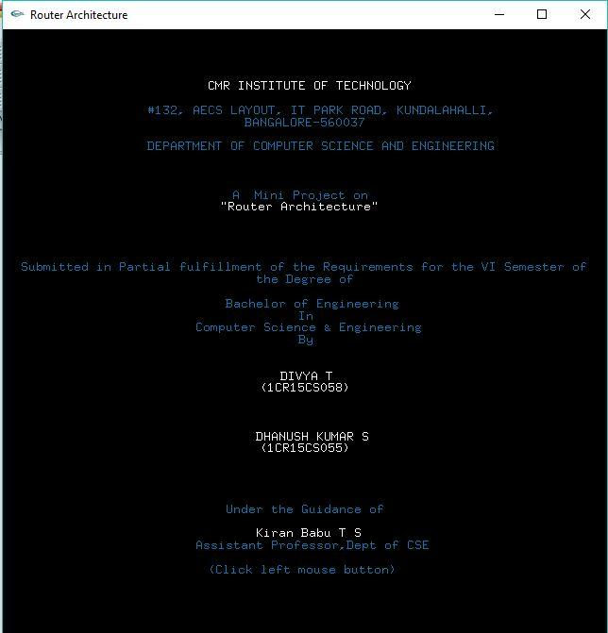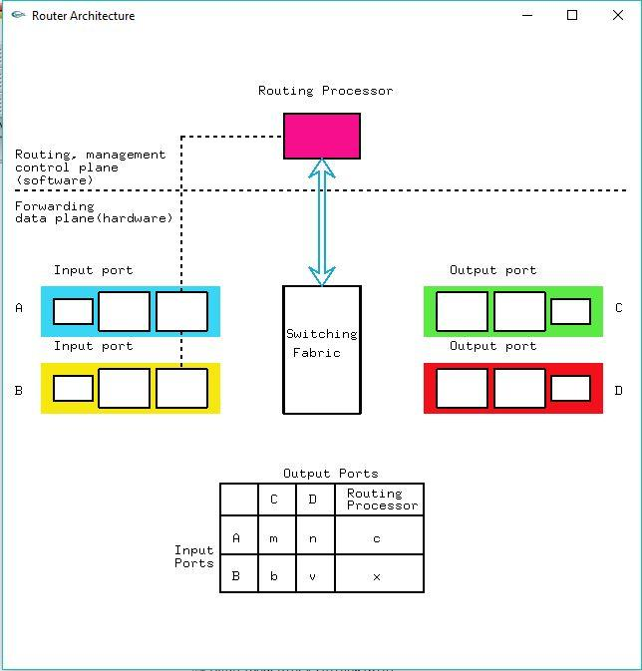

**Fig 4.2.1** Welcome Page **Fig 4.2.2** Router Architecture

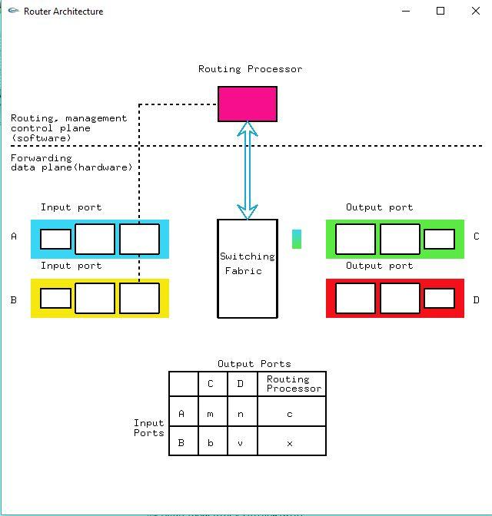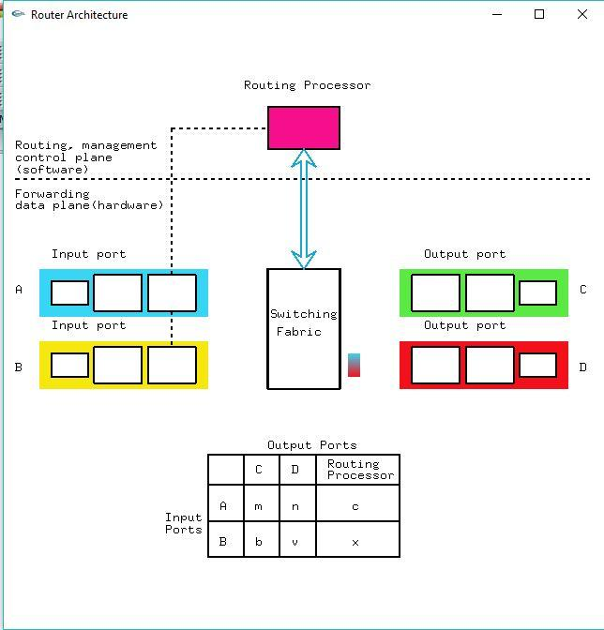

**Fig 4.2.3** Packet moving from Input port A **Fig 4.2.4** Packet moving from Input port A

to output port C to output port D

**Fig 4.2.5** Packet moving from Input port B **Fig 4.2.6** Packet moving from Input port B 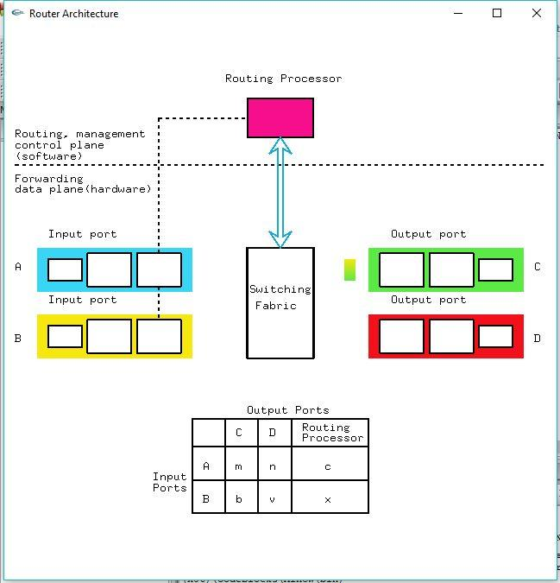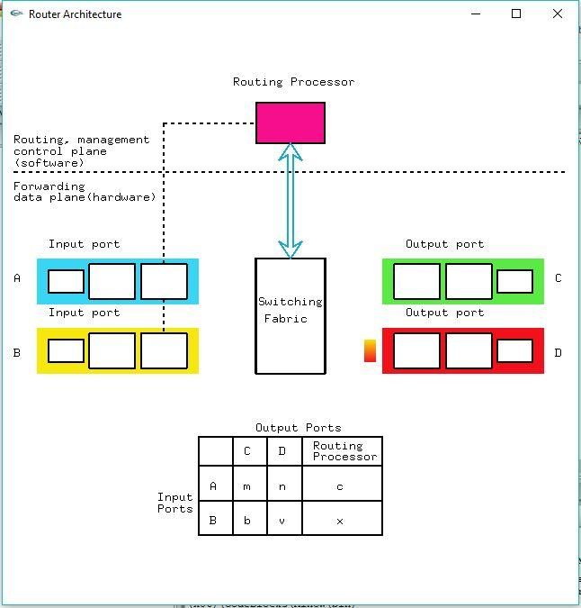

to Output port C to Output Port D  
 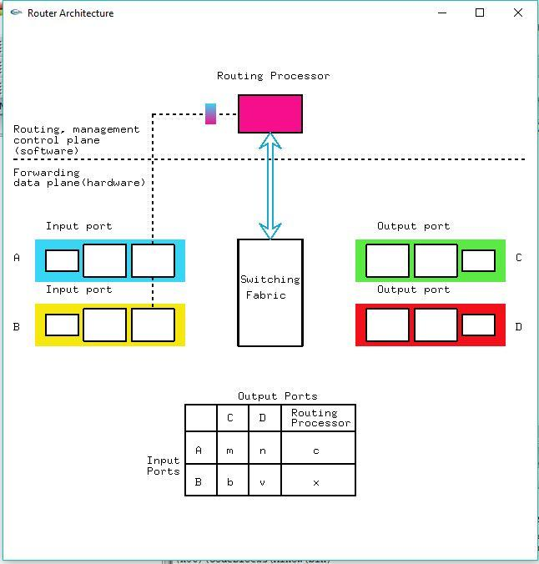

**Fig 4.2.7** Packet moving from Input port A

to Routing Processor

**CHAPTER 5**

**CONCLUSION AND FUTURE SCOPE**

By implementing this project I got to know how to use some of the built in functions effectively and how to interact efficiently and easily. I got a good exposure of how games, animation and simulations are developed, by working on this project.

The OpenGL Utility Toolkit (GLUT) is a programming interface with ANSI C bindings for writing window system independent OpenGL programs.

One of the major accomplishments in the specification of OpenGL was the isolation of window system dependencies from OpenGL’s rendering model. The result is that OpenGL is window system independent. Window system operations such as the creation of a rendering window and the handling of window system events are left to the native window system to define. Necessary interactions between OpenGL and the window system such as creating and binding an OpenGL context to a window are described separately from the OpenGL specification in a window system dependent specification.

The GLUT application-programming interface (API) requires very few routines to display a graphics scene rendered using OpenGL. The GLUT API (like the OpenGL API) is stateful. Most initial GLUT state is defined and the initial state is reasonable for simple programs. The GLUT routines also take relatively few parameters. No pointers are returned. The only pointers passed into GLUT are pointers to character strings (all strings passed to GLUT are copied, not referenced) and opaque font handles.

**BIBLIOGRAPHY**

* Google for problem solving
* Donald Hearn & Pauline Baker: Computer Graphics-OpenGL Version,3rd Edition, Pearson Education,2011
* Edward Angel: Interactive computer graphics- A Top Down approach with OpenGL, 5th edition. Pearson Education, 2011
* M MRaikar, Computer Graphics using OpenGL, Fillip Learning / Elsevier, Bangalore / New Delhi (2013)
* <https://stackoverflow.com/>
* **“**Computer Graphics”, Addison-Wesley 1997 James D Foley, Andries Van Dam, StevenK Feiner, John F Hughes.
* F.S.Hill and Stephen M.Kelly, “Computer Graphics using OpenGl “, 3rd edition
* [http://www.opengl.or](http://www.opengl.org/)g
* http:// [www.openglprojects.i](http://www.openglprojects.in/)n
* [http://www.openglprogramming.com](http://www.openglprogramming.com/)/
* http://www.google.com/